**Design Document**

**Authors**: Lucas Loaiza, Siegfred Madeghe, Shang Wang, and Noah Zhang

**1 Design Consideration**

**1.1 Assumptions**

The following requirements were assumed for the app:

* Allow the user to be able to monitor the battery usage.
* Create a list of applications that are currently running or in the background.
* Users should be able to order the applications in the list alphabetically.
* The system should provide a graphical view for the battery usage data (showing battery percentage).
* The system should trigger and alarm the user when battery level is below a certain value (10% should be a good number).
* The app should be easy to use and learn for different users.

**1.2 Constraints**

The system assumes that the user has granted PACKAGE_USAGE_STATS permissions. The system will prompt the user for permissions, but it will then assume that permissions are approved.

**1.3 System Environment**

We assume the system is running on an Android Nexus 6, using API 30 - Android 11. However, the system should work on any device running API 21 - Lollipop, or higher.

**2 Architectural Design**

**2.1 Component Diagram***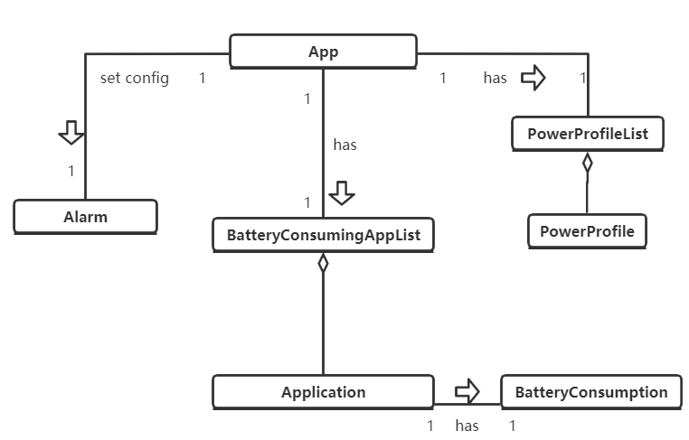*

**3 Low-Level Design**

**3.1 UML Diagram (with original requirements)**

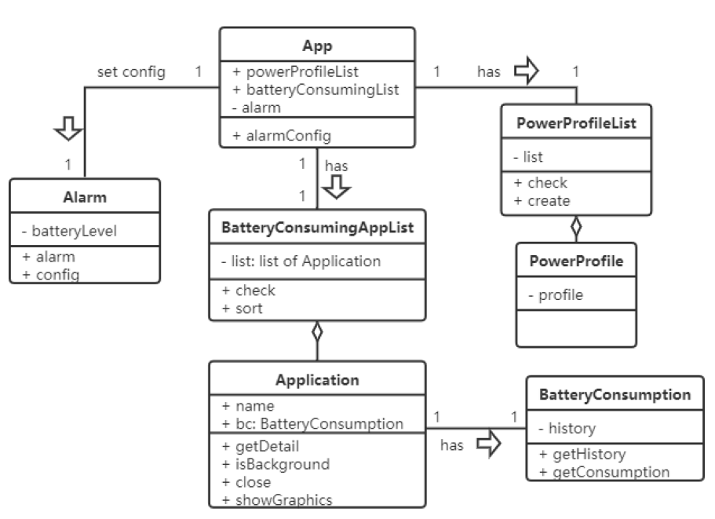

**4 User Interface Design**

**4.1 Initial UI (Before change in requirements)**

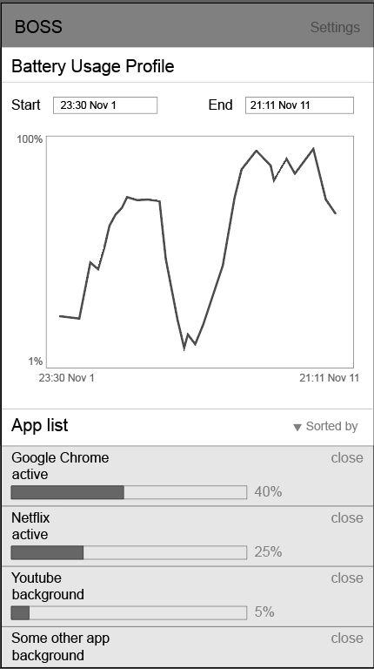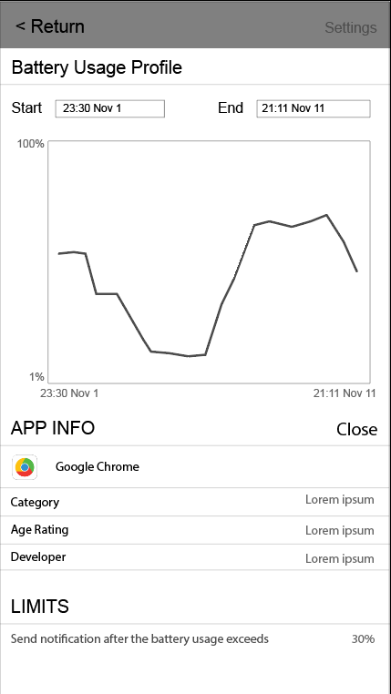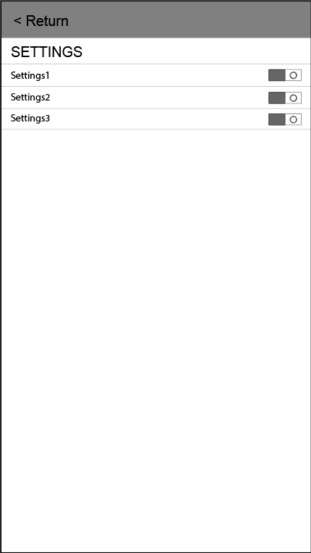

**4.2 Final UI**

